# Introduction

As surprising as it may sound, many new R programmers are unaware of Base R syntax and the powerful functions that come with it- many of which do what functions from packages like dplyr and the rest of the tidyverse do. In this short blog post I am going to talk about the within() function and its synonmity of the dplyr package’s mutate() function.

The lore that I heard around the within() function and mutate() stems from healthy competition between RStudio and the R-Core to create a function that does exactly what they do. If someone has a verifiable source for this I would love to see it myself!

For the example I will be using the all too classic iris data set for demonstration purposes.

# The Question

Suppose we’re interested in creating new variables that will give us the sepal length/width ratio for each flower measured. How would we do this?

# Using mutate()

mutate() is generally written by piping the data set to the function and then defining the variables. For brevity, I’ll just show the first six rows.

library(dplyr)

iris %>% mutate(Sepal.LWRatio=Sepal.Length/Sepal.Width) %>% head()

**Sepal.Length Sepal.Width Petal.Length Petal.Width Species Sepal.LWRatio**

|  |  |  |  |  |  |
| --- | --- | --- | --- | --- | --- |
| 5.1 | 3.5 | 1.4 | 0.2 | setosa | 1.457143 |
| 4.9 | 3.0 | 1.4 | 0.2 | setosa | 1.633333 |
| 4.7 | 3.2 | 1.3 | 0.2 | setosa | 1.468750 |
| 4.6 | 3.1 | 1.5 | 0.2 | setosa | 1.483871 |
| 5.0 | 3.6 | 1.4 | 0.2 | setosa | 1.388889 |
| 5.4 | 3.9 | 1.7 | 0.4 | setosa | 1.384615 |

# Using within()

Interestingly enough, we could do the same thing with within() as well! The syntax looks pretty similar to mutate()‘s if I were to not utilize pipes.

head( within(iris,{

Sepal.LWRatio = Sepal.Length/Sepal.Width

})

)

**Sepal.Length Sepal.Width Petal.Length Petal.Width Species Sepal.LWRatio**

|  |  |  |  |  |  |
| --- | --- | --- | --- | --- | --- |
| 5.1 | 3.5 | 1.4 | 0.2 | setosa | 1.457143 |
| 4.9 | 3.0 | 1.4 | 0.2 | setosa | 1.633333 |
| 4.7 | 3.2 | 1.3 | 0.2 | setosa | 1.468750 |
| 4.6 | 3.1 | 1.5 | 0.2 | setosa | 1.483871 |
| 5.0 | 3.6 | 1.4 | 0.2 | setosa | 1.388889 |
| 5.4 | 3.9 | 1.7 | 0.4 | setosa | 1.384615 |

# Interchangeability

Its important to note the way I wrote the above codes is only how I would personally use them. There are no hard rules for them. I can easily write the above codes with or without ‘tidy’ syntax.

# Looks like mutate()

iris %>% within({

Sepal.LWRatio = Sepal.Length/Sepal.Width

}) %>% head()

# Looks like within() head(

mutate(iris,

Sepal.LWRatio = Sepal.Length/Sepal.Width)

)

# Which one is faster

Now for what really matters. Which one is faster? For this we will use the rbenchmark package. To make the game as even as possible I will not incorporate any pipes which may slow the code down.

library(rbenchmark)

benchmark(

'mutate()'=mutate(iris, Sepal.LWRatio = Sepal.Length/Sepal.Width), 'within()'=within(iris,{Sepal.LWRatio<-Sepal.Length/Sepal.Width}), replications = 1000

)

**test replications elapsed relative user.self sys.self user.child sys.child**

|  |  |  |  |  |  |  |
| --- | --- | --- | --- | --- | --- | --- |
| mutate() 1000 | 1.60 | 8.889 | 1.56 | 0.02 | NA | NA |
| within() 1000 | 0.18 | 1.000 | 0.17 | 0.00 | NA | NA |

Looking at this visually, we see that within() is much faster than mutate(). Very interesting indeed.

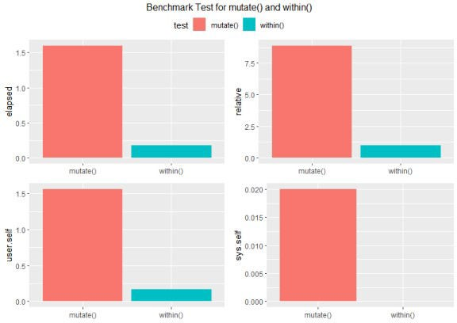

# Which one uses more Memory.

Now lets talk about production. In order to ensure that applications are lightweight, memory use is essential. In order to check how much memory is used, we will use Hadley Wickham’s pryr package.

library(pryr)

df<- tibble::tibble(

`Function`=c('mutate','within'), Bytes=c(object_size(mutate),object_size(within)))

df

**Function Bytes**

mutate() 1312

within() 1296

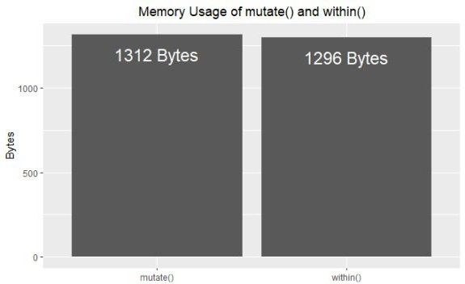

mutate() is slightly larger than within in terms of memory, but the size difference is minute. In terms of application size, I wouldn’t sweat it with that much of a size difference (unless you will be using mutate() multiple times in your code).

# Conclusion

As far as I can see, Base R’s within() is a faster alternative to dplyr‘s mutate(). I’m sure there is something even faster out there with data.table but I have to still spend some time with it. (If you know some data.table code for this I would love to see it!)